MB102 Breadboard Module Adapter Shield 3.3V/5V For Arduino Board
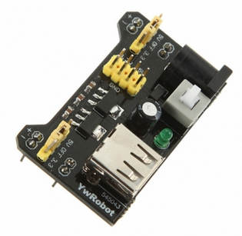
Description:
Breadboard power supply module, compatible with 5 V, 3.3 V
Apply to MB102 breadboard
Input voltage: 6.5-12 V (DC) or USB power supply
Output voltage: 3.3V/5V can switch over
Maximum output current: <700 ma
Fluctuation two road independent control, can switch over to 0 V, 3.3 V, 5 V
On-board two groups of 3.3V, 5V DC output plug pin, convenient external lead use.
Size: 5.3*3.2*2.5cm
Weight: 12g
Please notice: this item only a Power Supply Module, Breadboard is not included.

Forum link: https://www.facebook.com/123Neonado

